# To Install Before 9/26/2019

# Software

## R & Rstudio

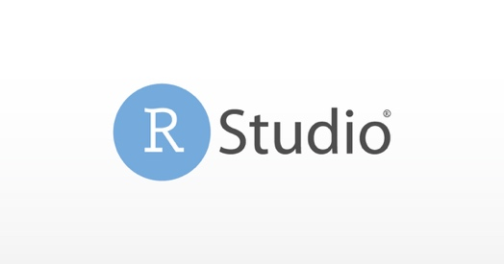

Install R first:

<https://cran.r-project.org>

Then install RStudio Desktop

<https://www.rstudio.com>

To make Rmarkdown documents, we’ll need to install the rmarkdown package and LaTeX: follow instructions [here](https://bookdown.org/yihui/rmarkdown/installation.html).

# OSF account

OSF logo

If you don’t have an account already, sign up at <https://osf.io>

Once you sign up, we’ll add you as *contributors* to the class example page

Public-facing example: <https://osf.io/ajtcw/>

Example for this class: <https://osf.io/wpqsv/>

# Advanced & Optional

## GIT

What is GIT? Decentralized repository for sharing, collaborating, and version control.



If you don’t have an account already, sign up at https://github.com/git

## GIT for desktop

<https://desktop.github.com>

